M.A. Jones Elementary School
Date: November 13, 2025
Time: 4:19pm-6:12pm
Location: Zoom & YouTube

- Call to Order: 4:19pm

- Roll Call
Role | Name | Present or Absent
Principal | Teruko Dobashi | Present
Parent/Guardian | Ayana Dunston | Present
Parent/Guardian | Meghan Plumb | Absent
Parent/Guardian | Shyretha Sheats | Present
Instructional Staff | Janni Buggs | Present
Instructional Staff | Cole Pryor | Present
Instructional Staff | Latoya Bostic | Present
Community Member | Melissa Waller | Present
Community Member | Raquel Hudson | Present
Swing Seat | Krista Verdelotti | Present

Quorum is met.

- Action Items
  - Approval for Agenda
    - MOTION: Verdelotti
    - SECOND: Dunston
    - RESULTS: Motion passed
  - Approval of Previous Minutes of October 9, 2025
    - MOTION: Hudson
    - SECOND: Plumb
    - RESULT: Motion passed unanimously

- Discussion Items
  - School Vision
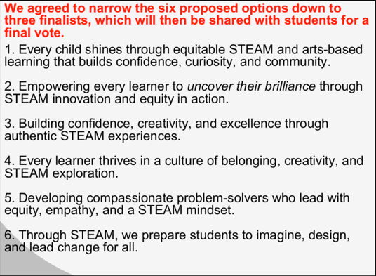
    - TIE: 1&2
      - TIE Breaker: 2
        - Dunston to edit & add comma between STEAM and innovation: “Empowering every leaner to uncover their brilliance through STEAM, innovation and equity in action.”
    - FINAL: 2, 4, 6
  - School Mission
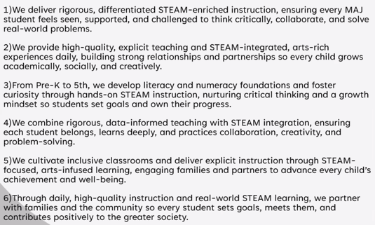
    - 1, 2 & 3
  - GOTeam narrowed Mission & Vision to 3 each. Dobashi will take to staff for final vote.
  - Strategic Plan & Priorities

    - Change Strategic #4
      - FROM: Our Strength is Our Team > Staff Engagement > % of engaged staff is 33.3% (2025) to 49.1% (2030) TO: % of students scoring ‘Demonstrating’ or ‘Exceeding’ on all ELA domains in Spring GKIDS 2.0 from 21.6% (2025) to 42.6% (2030)
          - Motion: Pryor
          - Second: Bostic
          - Passes Uniamious

  - School Updates:
    - 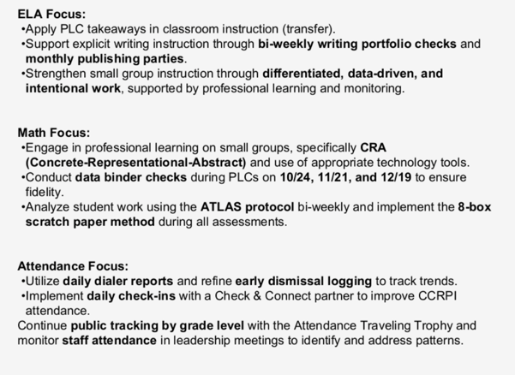
    - STEAM Recertification:
      - 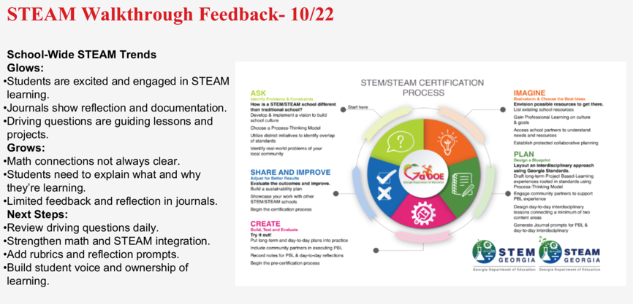
    - Cluster Advisory Team Report
      - 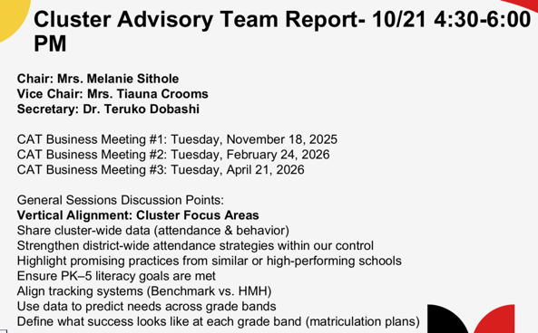
        - Looking to reassign lead teams, as it is all principal’s at next meeting.
    - APS Forward 2040:
      - 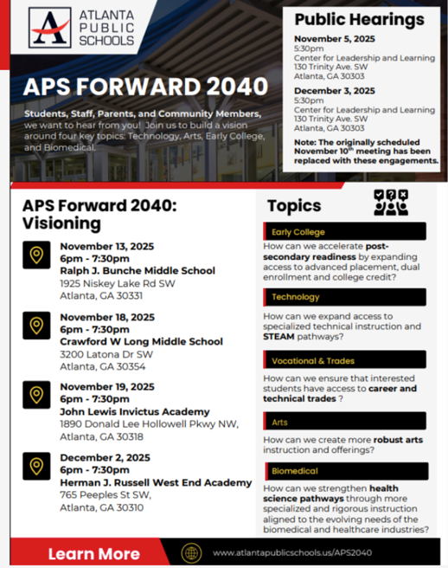
        - Verdelotti: tonight was the first public comment meeting since last roll out of scenario’s. There are a couple more before final vote on December 3.
          - District 2 Seat for APS is in a Run Off, December 2.

- Announcements
  - November 20, 2025:
    - Science Fair Night @ 9am
    - Publishing Party @ 1-2pm
    - STEAM Night @ 430pm
  - Thanksgiving Break, NO SCHOOL: November 24-November 28, 2025
  - BETA Trip: December 2-December 4, 2025
  - MAP/AMIRA Testing: December 1-December 12, 2025
  - Plumb Family is rolling off after this month. Her family is relocating. Thankful for her time here.

- NO PUBLIC COMMENTS

- Adjournment
  - MOTIONED: Hudson
  - SECONDED: Bostic
  - RESULT: Motion passed

ADJOURNMENT at 6:12PM
--------------------------------------------------------------------------------------------------------------------------
Minutes Taken By: Krista Verdelotti
Position: Secretary
Date Approved:

